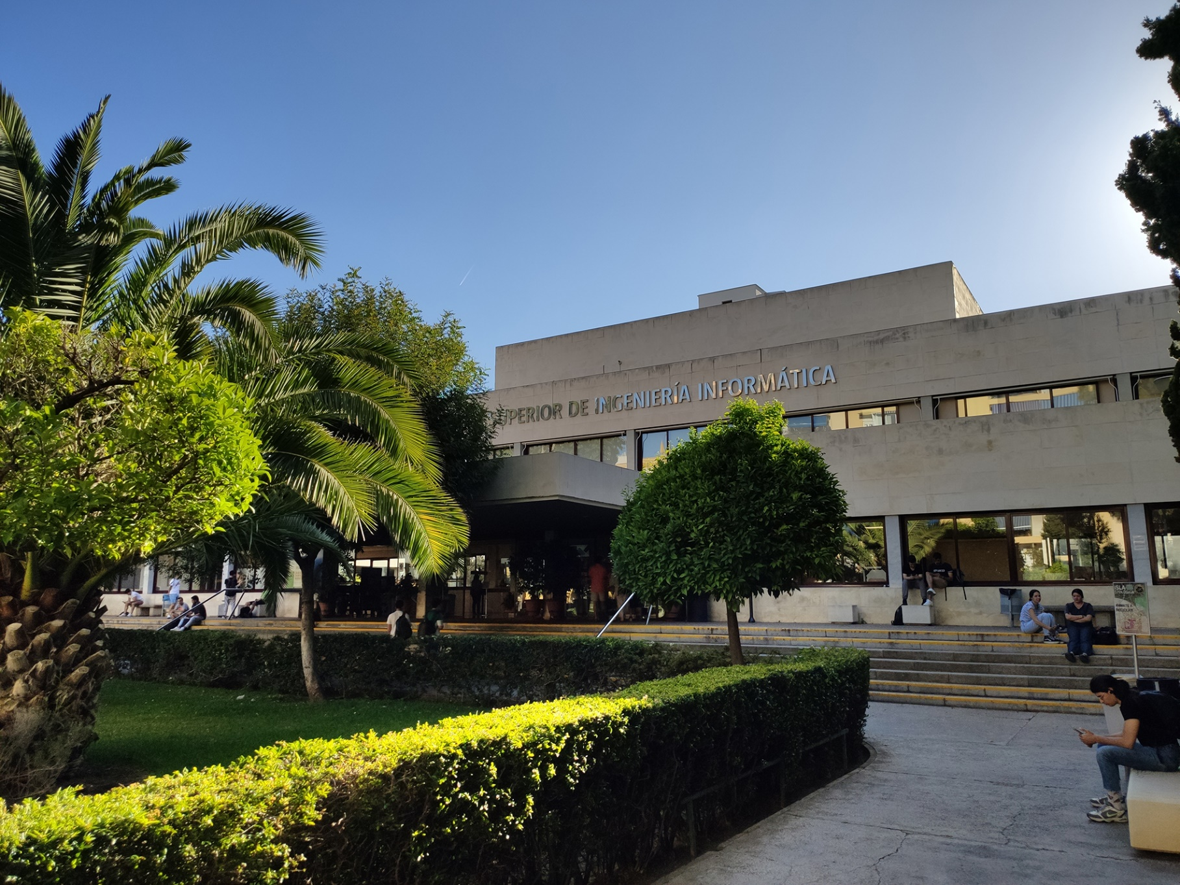

|  |
| --- |
| Knowledge  of a WIS  Report |
| Members:   1. Jesús Cárdenas Conejo   (jescarcon@alum.us.es)   1. Antonio José López Cubiles   (antlopcub@alum.us.es)   1. Pedro Jesús Ruiz Aguilar   (pedruiagu1@alum.us.es)   1. Ismael Ruiz Jurado   (ismruijur@alum.us.es) |
| 16-02-2023  Group: C1.02.10  Repository: https://github.com/jescarcon/Acme-L3-D01-23.1 |



Table of Contents

Executive Summary 3

Version History 4

Introduction 5

Contents 6

Conclusions 7

Bibliography 8

# Executive Summary

Intentionally blank. (Because in this specific report, is equivalent to the introduction)

# Version History

|  |  |  |
| --- | --- | --- |
| Version | Date | Description of changes |
| V1.0 | 16/02/2023 | Making the report |

# Introduction

In this report we are gonna explain our knowledge on a WIS architecture based on what we have seen and learned prior to the DP2 lessons.

# Contents

Based on what we have learned in previos subjects, such as AISS, DP1, IISSI, among others, we concieve a WIS architecture as a web based layer architecture, composed by the presentation layer, the logical layer and the database. The presentation layer is the layer that the user of the web directly interacts with, it can be known as frontend. The logical layer is the layer that makes the necessary operations in order to respond to what the user wants and requests in the presentation layer, it can be known as backend. The database consists in a collection of all the data that is needed in the logical layer or is created by an user using the application.

# Conclusions

In general terms, we know what a WIS architecture is about, and we refreshed our concept of it with the lesson.

# Bibliography

Intentionally blank.